Chapter 17, Solution 8.

Using Fig. 17.51, design a problem to help other students to better understand how to determine the exponential Fourier Series from a periodic wave shape.

Although there are many ways to solve this problem, this is an example based on the same kind of problem asked in the third edition.

Problem

Obtain the exponential Fourier series of the function in Fig. 17.51.

f(t)

5

t
0 1 2 3 4 5

Figure 17.51 For Prob. 17.8.

Solution

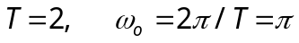
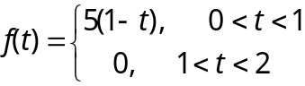

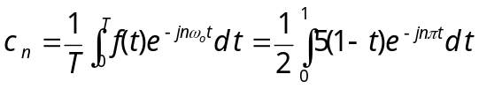
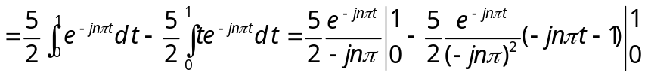
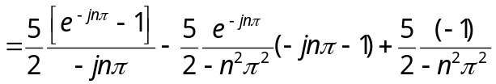

But
